Filtration & Crystallisation

Aim: To design and carry out practical work to try and separate pure samples of substances from a range of mixtures.
Safety: Goggles must be worn. Be careful using hot glassware.

Design/Plan:
You have a practical problem to solve in your team of 2 or 3 students. You need to design an experiment to separate a pure sample of salt from the rock salt.

- Brianstorm your plan on the additional note space on the next page.
- Draw labelled diagrams showing how you will need to set up the apparatus and explain what happens at each stage.
- Write a method using numbered points to explain what you will do.

Some of the apparatus below may help you decide what to do.

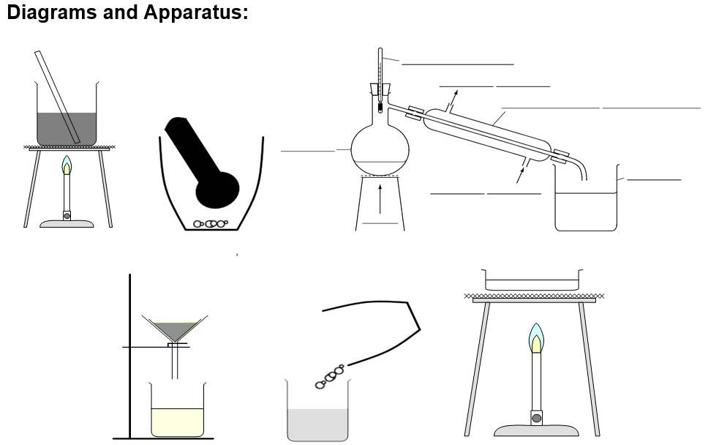

Planning Notes - design an experiment to separate a pure sample of salt from the rock salt.

Analysis / Conclusion

1) Explain (in terms of the particles involved) how you were able to separate a pure sample of salt from the rock salt.

2) If you started with 5g of rock salt and weighed the mass of pure salt obtained at the end and it was 4g, what % of salt is there in rock salt?

3) A student carried out this practical and the rock salt obtained was grey rather than pure white. What does this suggest and what could the student do next to test if the salt is pure?

4) What is the name of the process called when the crystals of pure salt start to appear? If a student weighed their salt crystals before the water had all evaporated away, would this be an accurate mass of salt? What should they do to improve the accuracy of the mass?

5) Henrique spilled some water onto a black kitchen worktop and did not wipe up the spill. The water looked clear. Eventually, the water dried but a white mark was left. What does this tell you about the water?
 | True | False | Insufficient evidence
The water was mixed with a white substance
The water was pure
The water contained a dissolved substance
The water was salty

